Git Project (2.5 Hours)

Objective:
You will work on a project involving a simple website. You will learn and practice various Git concepts including branching, merging, handling merge conflicts, rebasing, pulling, versioning, and rolling back changes. This project is designed to be completed in 1 hour.

Project Setup (15 minutes)
- Install Git: Ensure Git is installed on your system. Verify with git --version.
Set Up Git: Configure your Git username and email:
git config --global user.name "Your Name"
git config --global user.email "your.email@example.com"
- Create a GitHub Repository:
  - Go to GitHub and create a new repository named website-project.
Clone the repository to your local machine:
git clone https://github.com/your-username/website-project.git

- Initialize the Project:
Navigate to the project directory:
cd website-project

Create initial project structure:
mkdir src
touch src/index.html
echo "<!DOCTYPE html><html><head><title>My Website</title></head><body><h1>Welcome to my website!</h1></body></html>" > src/index.html

Commit and push the initial project structure:
git add .
git commit -m "Initial commit: Added project structure and index.html"
git push origin main

Exercise 1: Branching and Basic Operations (10 minutes)
Create a New Branch:
git checkout -b feature/add-about-page

- Add a New Page:
Create about.html:
touch src/about.html
echo "<!DOCTYPE html><html><head><title>About Us</title></head><body><h1>About Us</h1></body></html>" > src/about.html

Commit and push changes:
git add src/about.html
git commit -m "Added about page"
git push origin feature/add-about-page

Exercise 2: Merging and Handling Merge Conflicts (15 minutes)
Create Another Branch:
git checkout main
git checkout -b feature/update-homepage

- Update the Homepage:
Modify index.html:
echo "<p>Updated homepage content</p>" >> src/index.html

Commit and push changes:
git add src/index.html
git commit -m "Updated homepage content"
git push origin feature/update-homepage

- Create a Merge Conflict:
Modify index.html on the feature/add-about-page branch:
git checkout feature/add-about-page
echo "<p>Conflict content</p>" >> src/index.html
git add src/index.html
git commit -m "Added conflicting content to homepage"
git push origin feature/add-about-page

- Merge and Resolve Conflict:
Attempt to merge feature/add-about-page into main:
git checkout main
git merge feature/add-about-page

Resolve the conflict in src/index.html, then:
git add src/index.html
git commit -m "Resolved merge conflict in homepage"
git push origin main

Exercise 3: Rebasing (10 minutes)
- Rebase a Branch:
Rebase feature/update-homepage onto main:
git checkout feature/update-homepage
git rebase main

  - Resolve any conflicts that arise during rebase.
Push the Rebased Branch:
git push -f origin feature/update-homepage

Exercise 4: Pulling and Collaboration (10 minutes)
- Pull Changes from Remote:
Ensure the main branch is up-to-date:
git checkout main
git pull origin main

- Simulate a Collaborator's Change:
  - Make a change on GitHub directly (e.g., edit index.html).
- Pull Collaborator's Changes:
Pull the changes made by the collaborator:
git pull origin main

Exercise 5: Versioning and Rollback (15 minutes)
- Tagging a Version:
Tag the current commit as v1.0:
git tag -a v1.0 -m "Version 1.0: Initial release"
git push origin v1.0

- Make a Change that Needs Reversion:
Modify index.html:
echo "<p>Incorrect update</p>" >> src/index.html
git add src/index.html
git commit -m "Incorrect update"
git push origin main

- Revert to a Previous Version:
Use git revert to undo the last commit:
git revert HEAD
git push origin main

Alternatively, reset to a specific commit (use with caution):
sh
Copy code
git reset --hard v1.0
git push -f origin main

Extra Activities (10 minutes)
- Stashing Changes:
Make some local changes without committing:
echo "<p>Uncommitted changes</p>" >> src/index.html

Stash the changes:
git stash

Apply the stashed changes:
git stash apply

- Viewing Commit History:
Use git log to view commit history:
git log --oneline

- Cherry-Picking Commits:
Create a new branch and cherry-pick a commit from another branch:
git checkout -b feature/cherry-pick
git cherry-pick <commit-hash>
git push origin feature/cherry-pick

- Interactive Rebase:
Use interactive rebase to squash commits:
git checkout main
git rebase -i HEAD~3

Collaborative Blogging Platform

Objective:
You will work on a project to collaboratively develop a simple blogging platform. You will practice various Git concepts including branching, merging, handling merge conflicts, rebasing, pulling, versioning, rolling back changes, stashing, and cherry-picking commits. The project is designed to be completed in 1.5 Hours

- Create a GitHub Repository:
  - Go to GitHub and create a new repository named blogging-platform.
Clone the repository to your local machine:
git clone https://github.com/your-username/blogging-platform.git

- Initialize the Project:
Navigate to the project directory:
cd blogging-platform

Create initial project structure:
mkdir src
touch src/index.html
echo "<!DOCTYPE html><html><head><title>Blogging Platform</title></head><body><h1>Welcome to the Blogging Platform!</h1></body></html>" > src/index.html

Commit and push the initial project structure:
git add .
git commit -m "Initial commit: Added project structure and index.html"
git push origin main
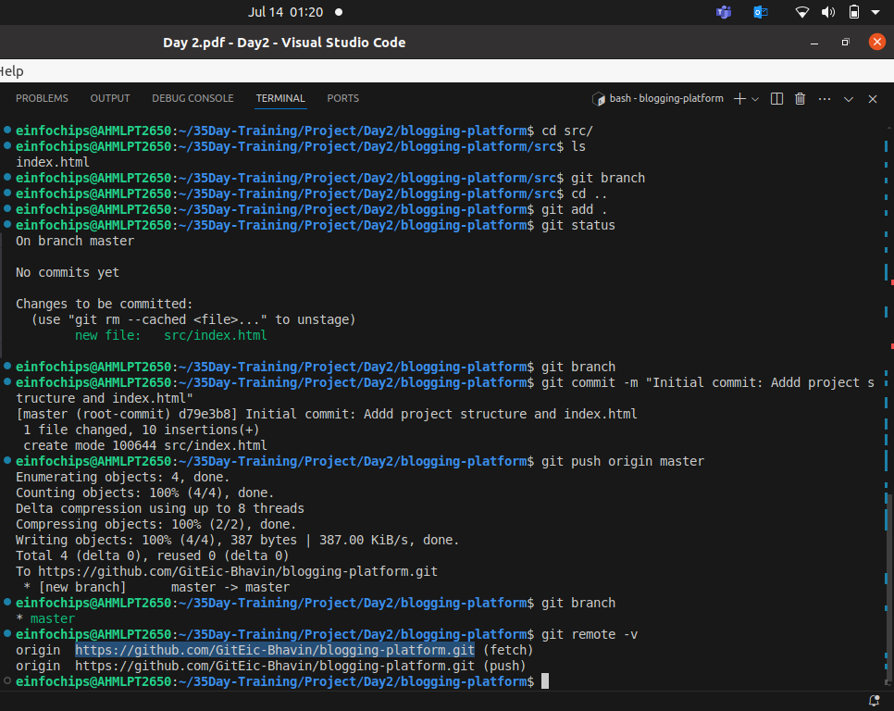

Exercise 1: Branching and Adding Features (20 minutes)
Create a New Branch for Blog Post Feature:
git checkout -b feature/add-blog-post
- Add a Blog Post Page:
Create blog.html:
touch src/blog.html
echo "<!DOCTYPE html><html><head><title>Blog Post</title></head><body><h1>My First Blog Post</h1></body></html>" > src/blog.html

Commit and push changes:
git add src/blog.html
git commit -m "Added blog post page"
git push origin feature/add-blog-post

Exercise 2: Collaborating with Merging and Handling Merge Conflicts (25 minutes)
Create Another Branch for Author Info:
git checkout main
git checkout -b feature/add-author-info

- Add Author Info to Blog Page:
Modify blog.html:
echo "<p>Author: John Doe</p>" >> src/blog.html

Commit and push changes:
git add src/blog.html
git commit -m "Added author info to blog post"
git push origin feature/add-author-info
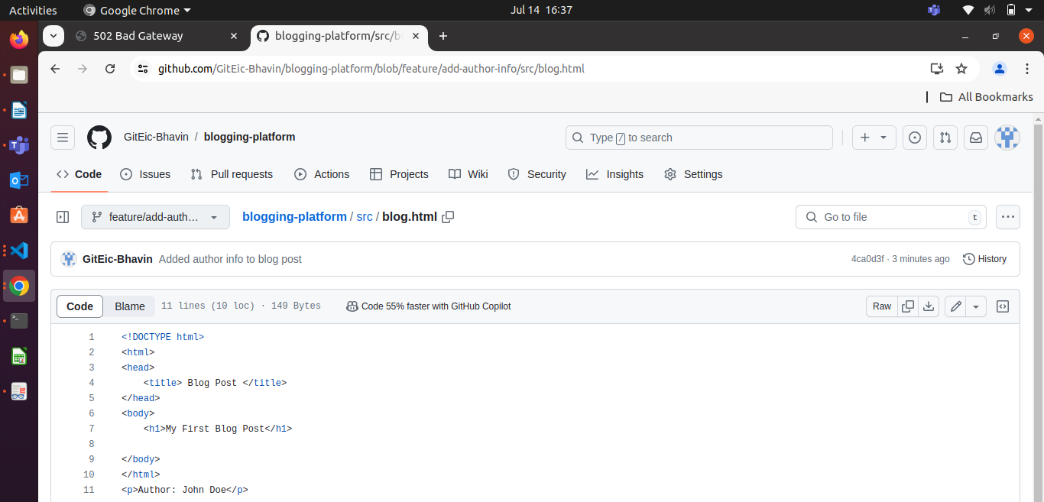
- Create a Merge Conflict:
Modify blog.html on the feature/add-blog-post branch:
git checkout feature/add-blog-post
echo "<p>Published on: July 10, 2024</p>" >> src/blog.html
git add src/blog.html
git commit -m "Added publish date to blog post"
git push origin feature/add-blog-post
Before commit new changes
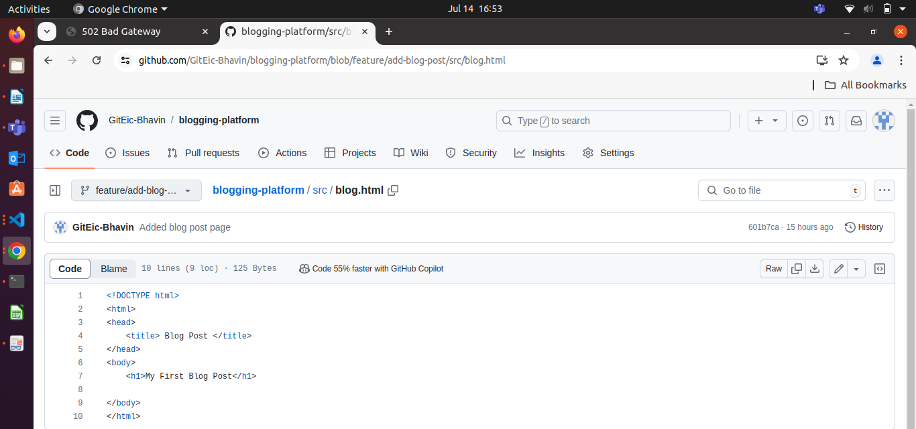
After commit new changes.
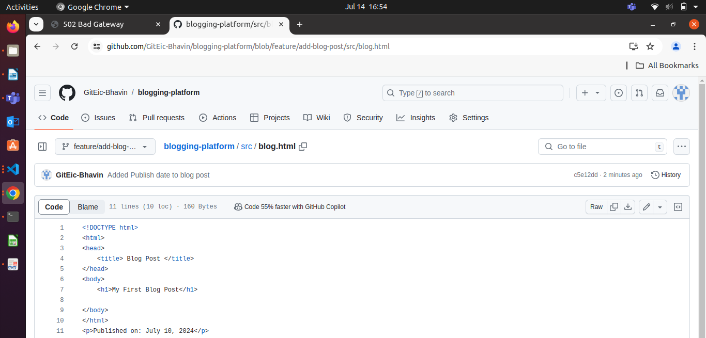
- Merge and Resolve Conflict:
Attempt to merge feature/add-blog-post into main:
git checkout main
git merge feature/add-blog-post
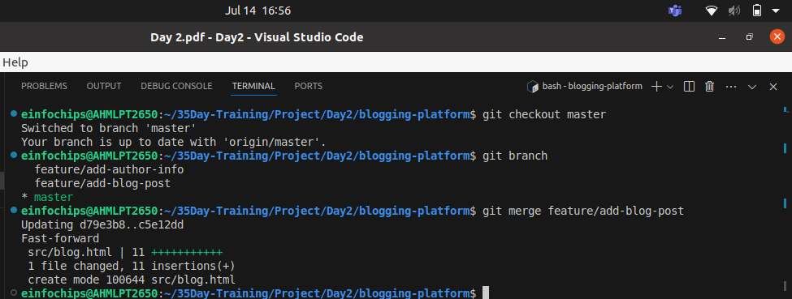
Resolve the conflict in src/blog.html, then:
git add src/blog.html
git commit -m "Resolved merge conflict in blog post"
git push origin main
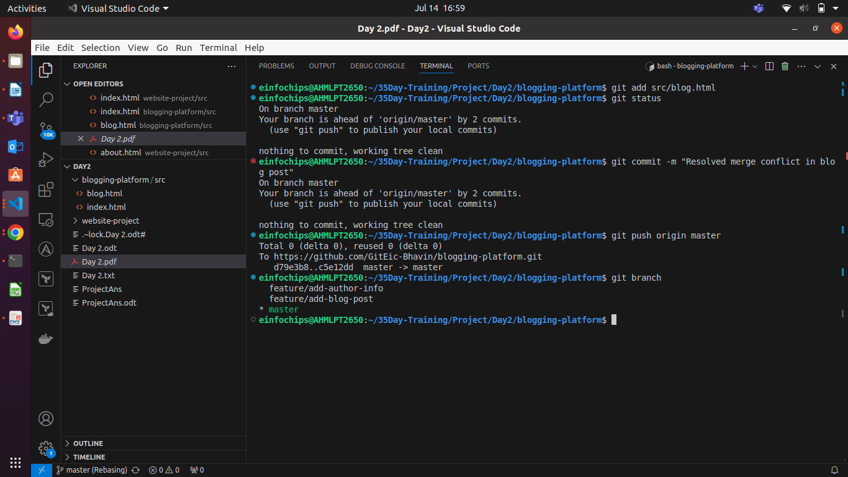

Exercise 3: Rebasing and Feature Enhancement (25 minutes)
- Rebase a Branch for Comment Feature:
Rebase feature/add-author-info onto main:
git checkout feature/add-author-info
Before rebase of master branch into feature/add/author-info
feature/add author info

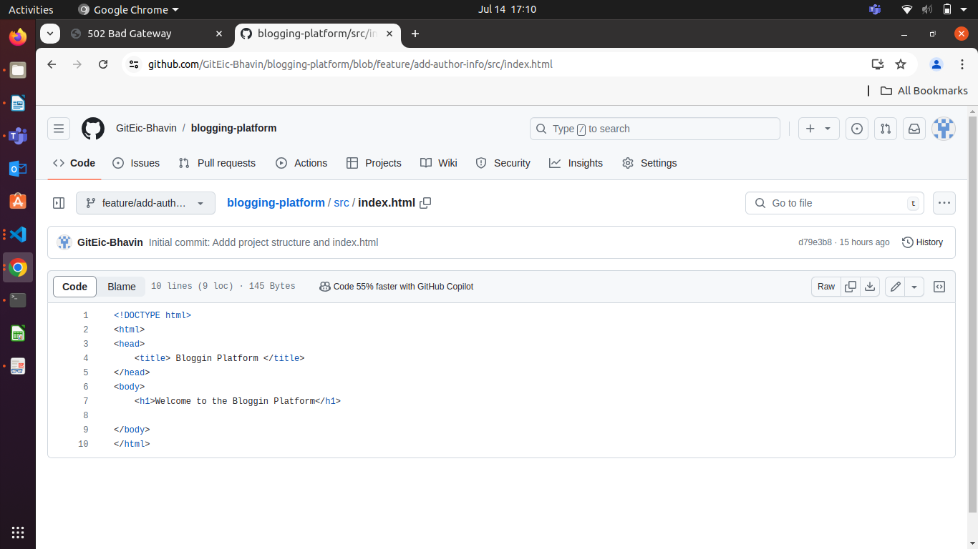

commit history
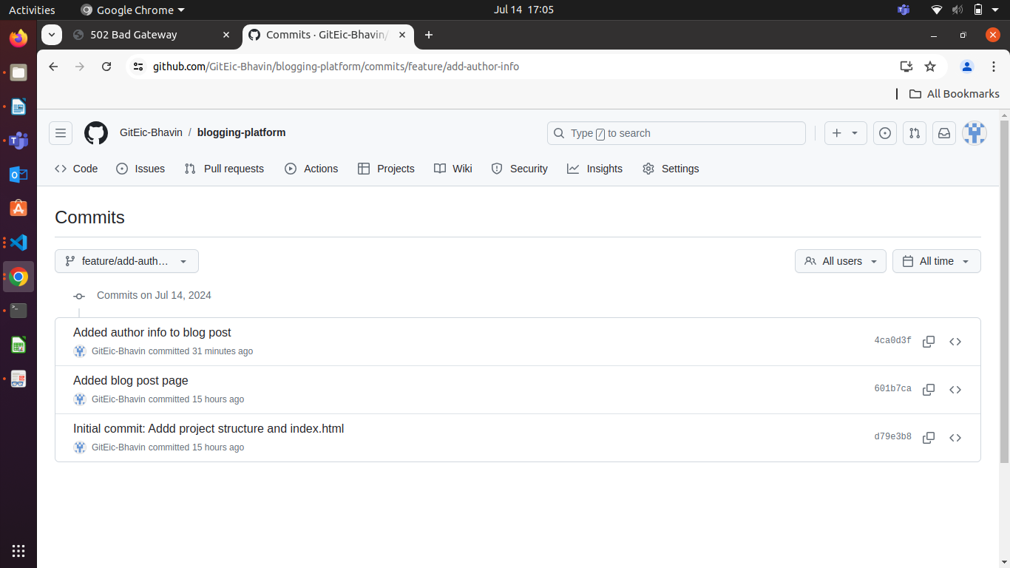
master commit history
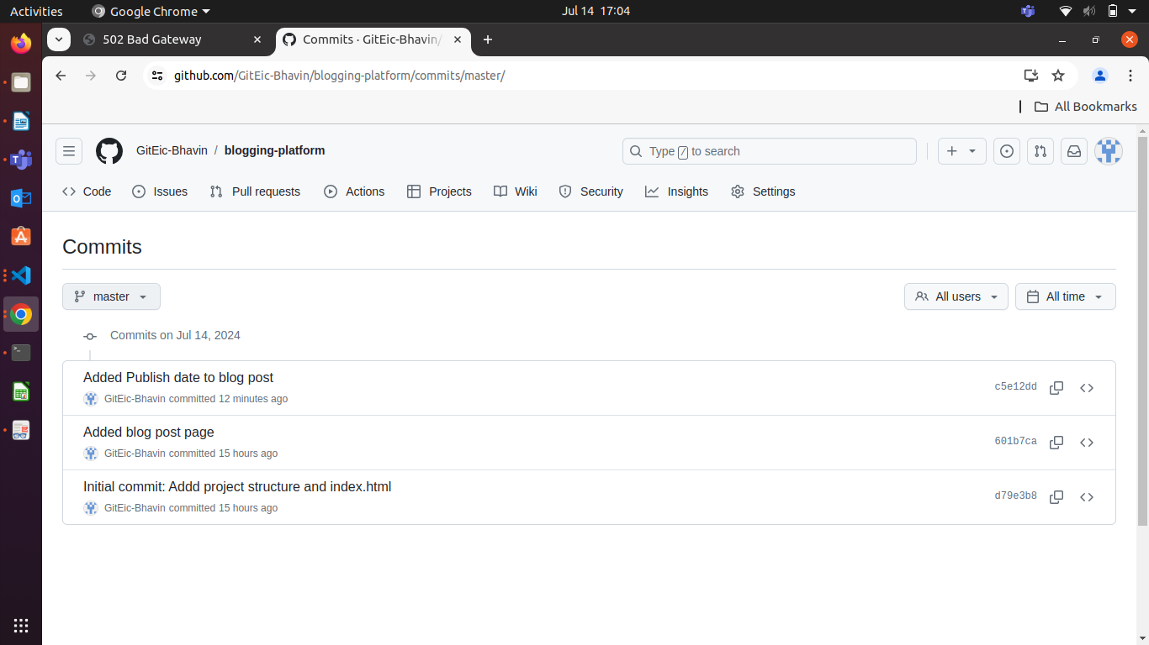

See File
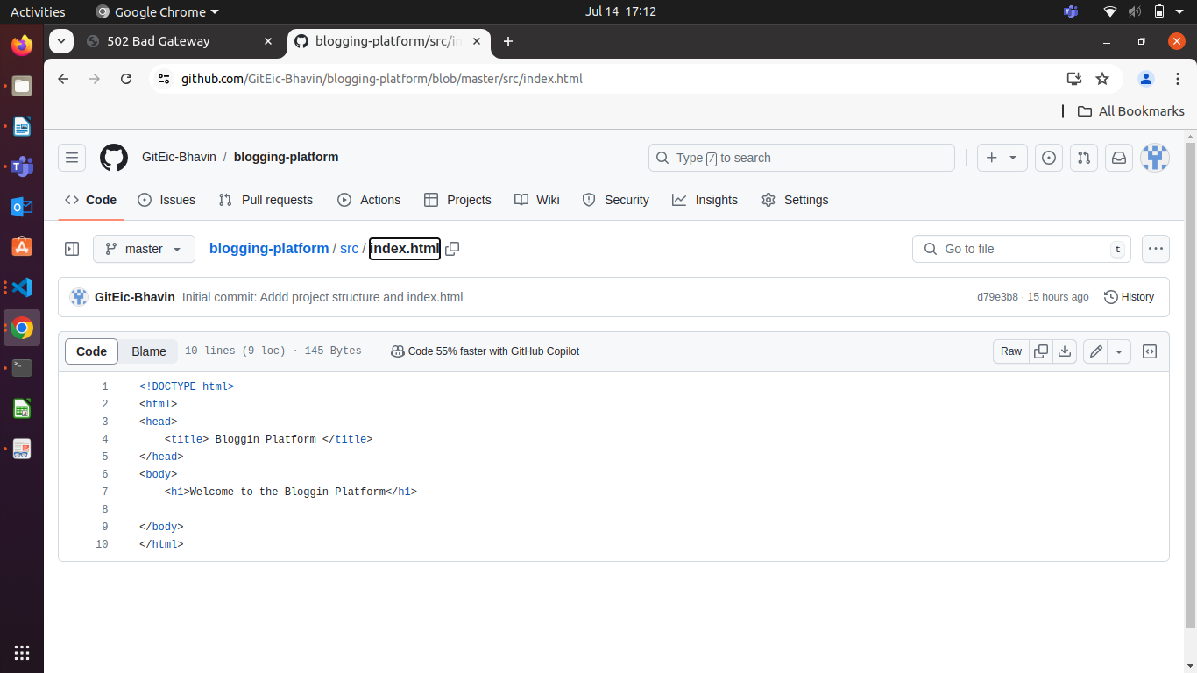

This file is same
See next file
blog.html master
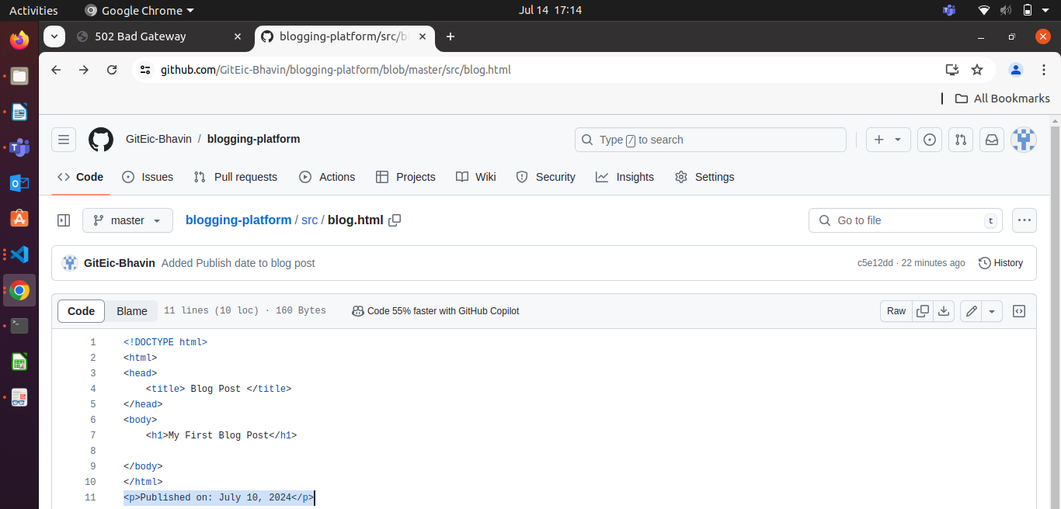

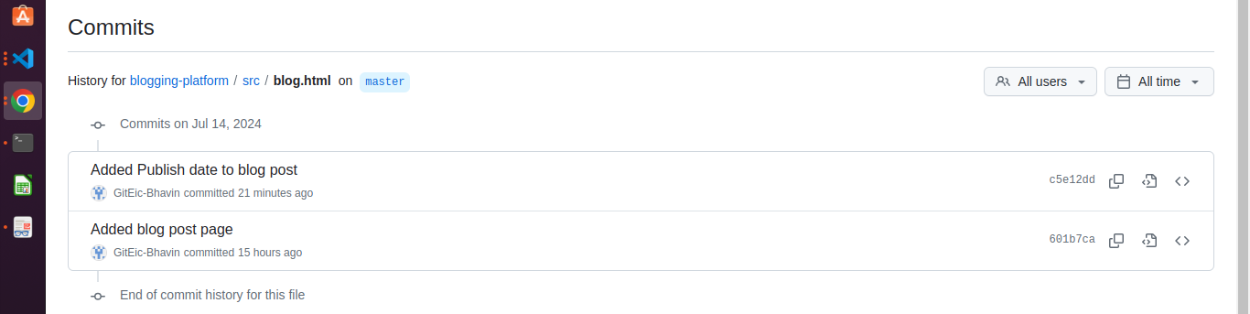
see commit history
See file blog.html feature/add-author-info
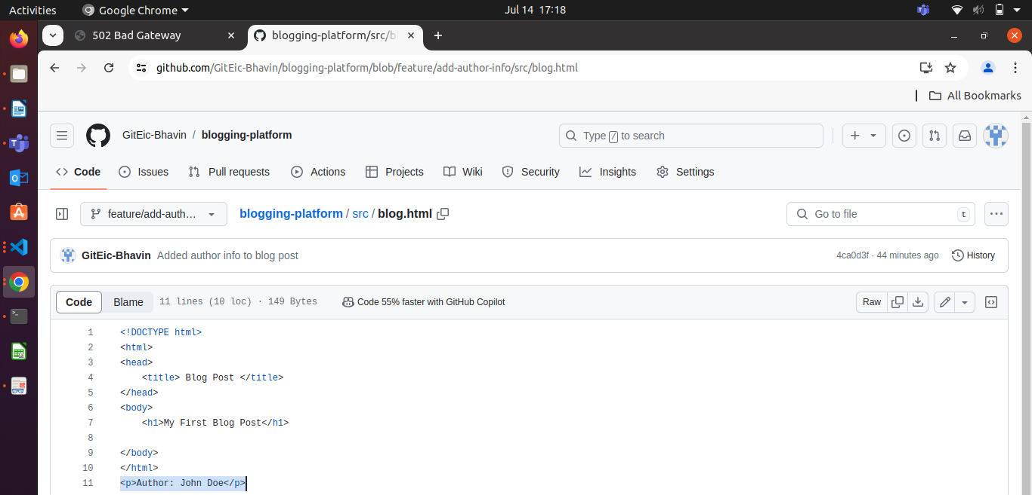

See commit history
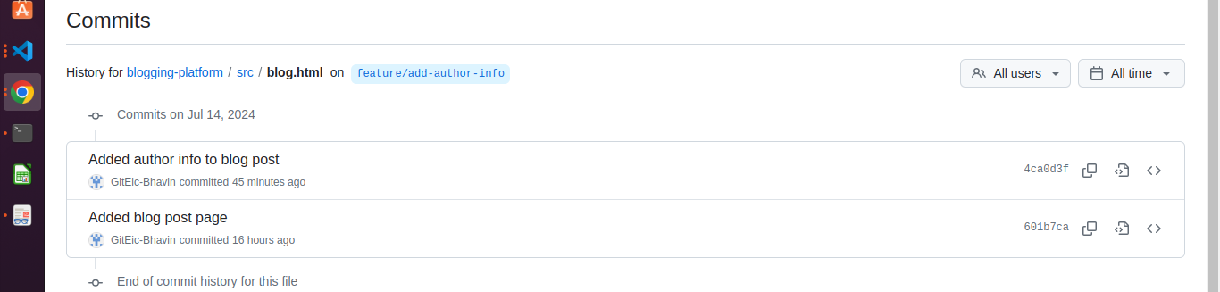

git rebase main
after rebase
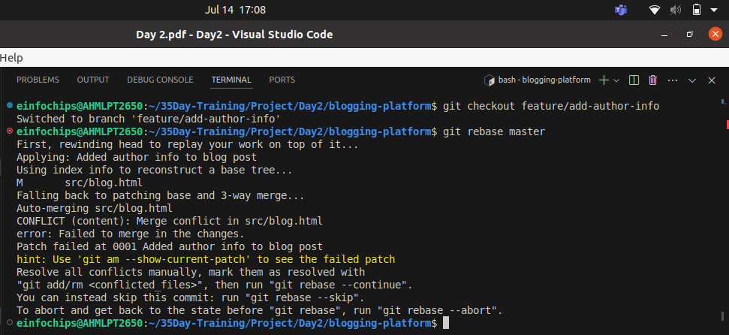

  - Resolve any conflicts that arise during rebase.

I got merge conflicts bcz, in blog.html file compaire line in below pics.
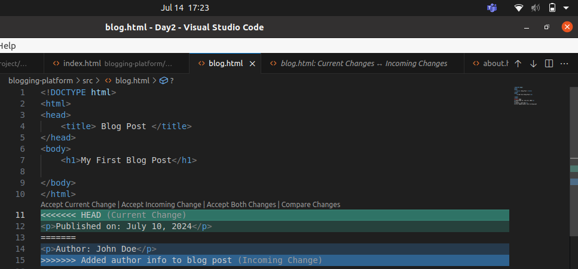
See, Option to resolve conflicts
Accept Current Change | Accept Incoming Change | Accept Both Changes | Compare Changes.

Here, <<<<< HEAD current change – is from my current branch MASTER.
Line is “<p>Published on: July 10, 2024</p>

Here, >>>>> Added author info to blog post (Incoming Change) – if from feature/add-author-info branch.

You have to decide which line you have to keep .
You have to del / add line is called “Merge”
but now, you are doing Rebasing.

In Rebasing , if you want to bring changes from specific commit like from commits 4 to all from feature/add-author-info branch to master branch. Is called Rebasing.

So, i will select Accept Both Changes. To do rebasing.
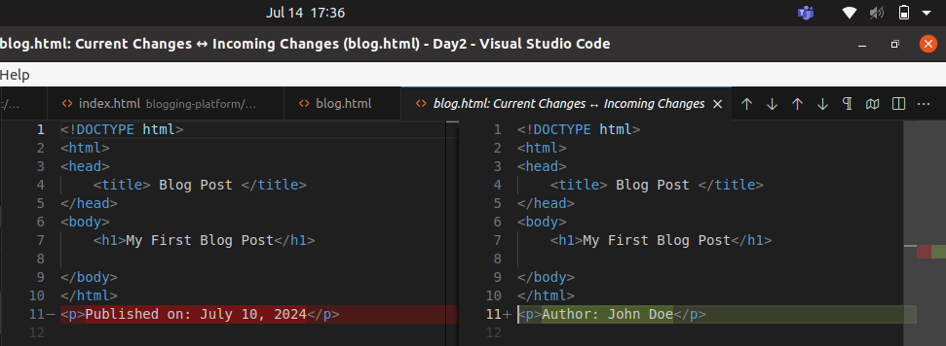

After Rebasing final file will be like this,
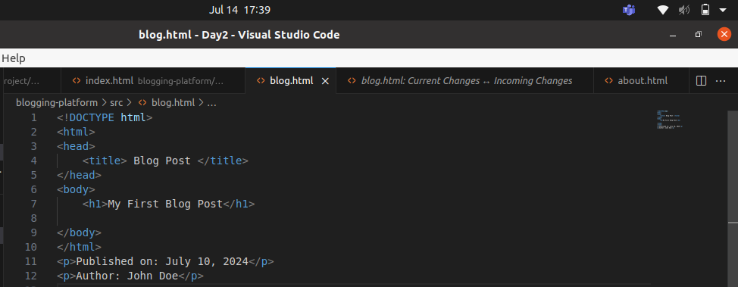

- Add Comment Section:
Modify blog.html to add a comment section:
echo "<h2>Comments</h2><p>No comments yet.</p>" >> src/blog.html
git add src/blog.html
git commit -m "Added comment section"
git push origin feature/add-author-info

Exercise 4: Pulling and Simulating Collaboration (20 minutes)
- Pull Changes from Remote:
Ensure the main branch is up-to-date:
git checkout main
git pull origin main

- Simulate a Collaborator's Change:
  - Make a change on GitHub directly (e.g., edit blog.html to add a new comment).
- Pull Collaborator's Changes:
Pull the changes made by the collaborator:
git pull origin main

Exercise 5: Versioning and Rollback (30 minutes)
- Tagging a Version:
Tag the current commit as v1.0:
git tag -a v1.0 -m "Version 1.0: Initial release"
git push origin v1.0

- Make a Change that Needs Reversion:
Modify blog.html:
echo "<p>Incorrect comment</p>" >> src/blog.html
git add src/blog.html
git commit -m "Incorrect comment update"
git push origin main

- Revert to a Previous Version:
Use git revert to undo the last commit:
git revert HEAD

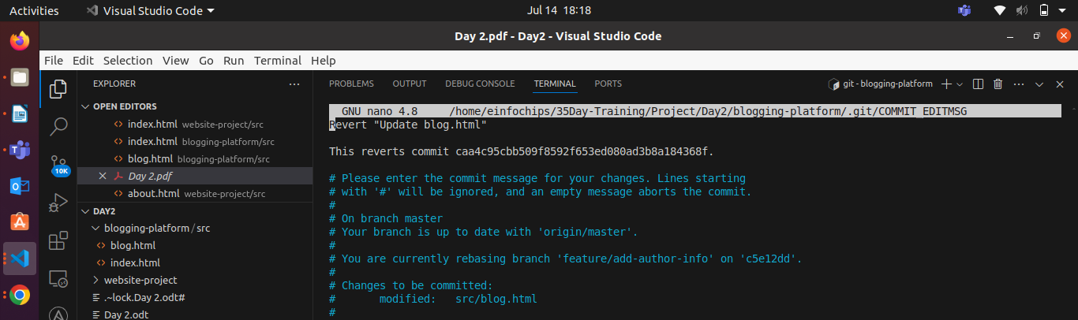
Here, write commit then, save & exit
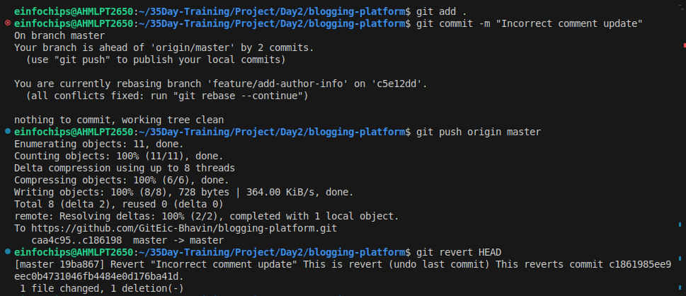
It will undo last commit that is “Incorrect commit update”
And come old one commit tag v1.0 & bring back / undo all commit of branch feature/add-author-info.
git push origin main
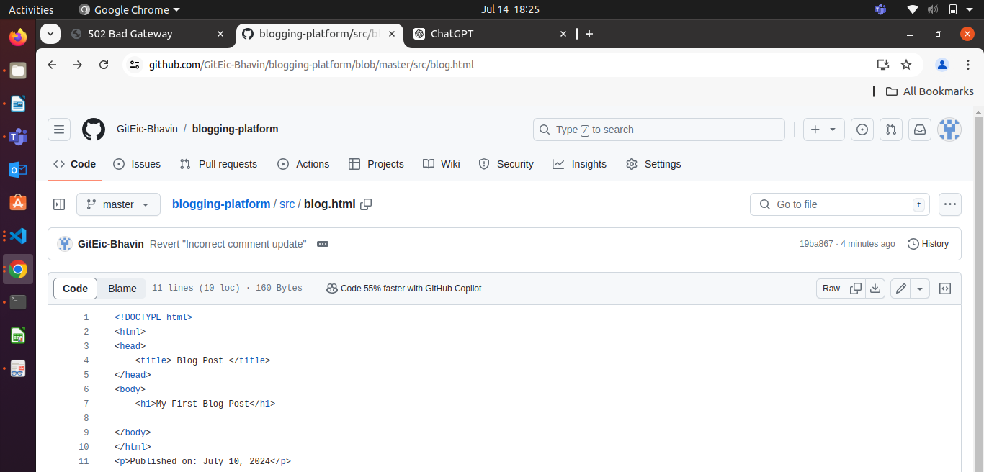

Alternatively, reset to a specific commit (use with caution):
git reset --hard v1.0
git push -f origin main

Extra Activities (25 minutes)
- Stashing Changes:
Make some local changes without committing:
echo "<p>Uncommitted changes</p>" >> src/blog.html
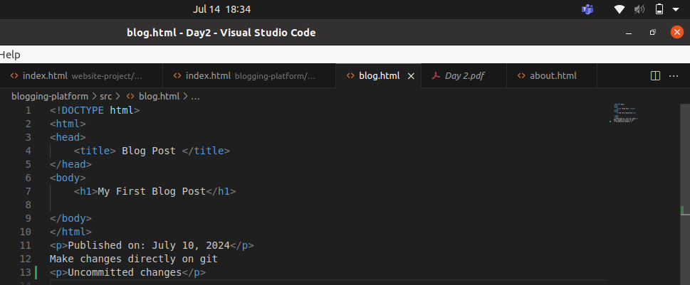

Stash the changes:
git stash
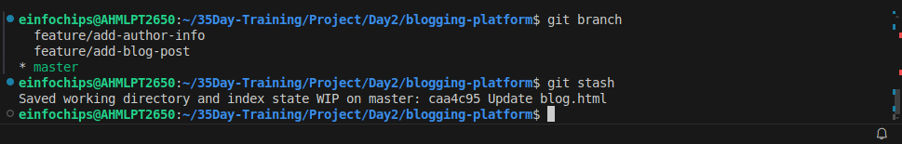
Now i will checkout into branch feature/add-authore-info
And do any changes. Then come back to master & git stash apply.

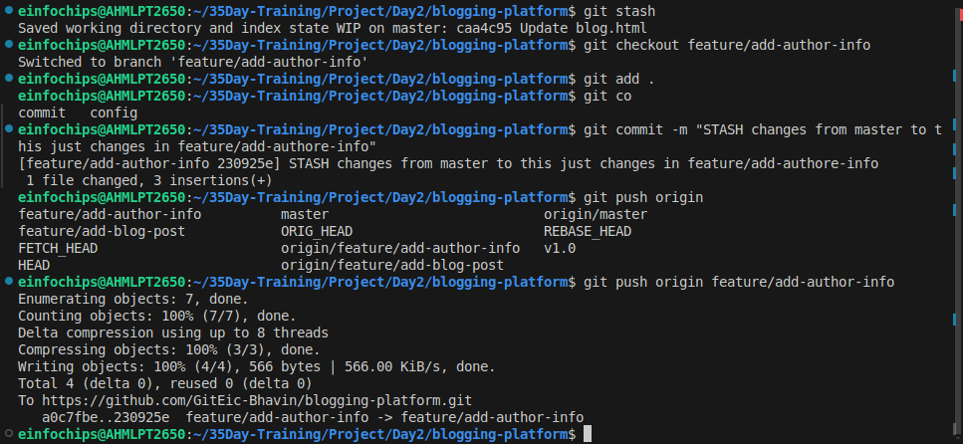

Apply the stashed changes:
git stash apply
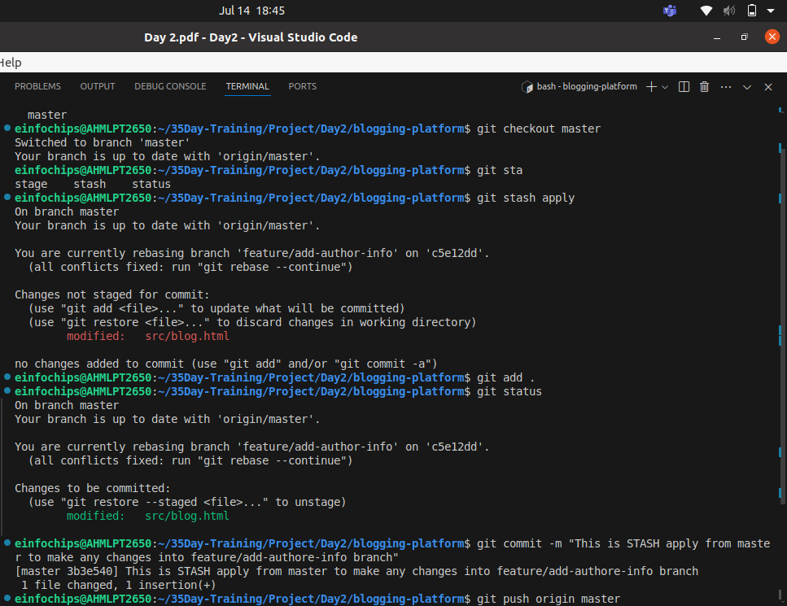

See Reflection of Stash on git
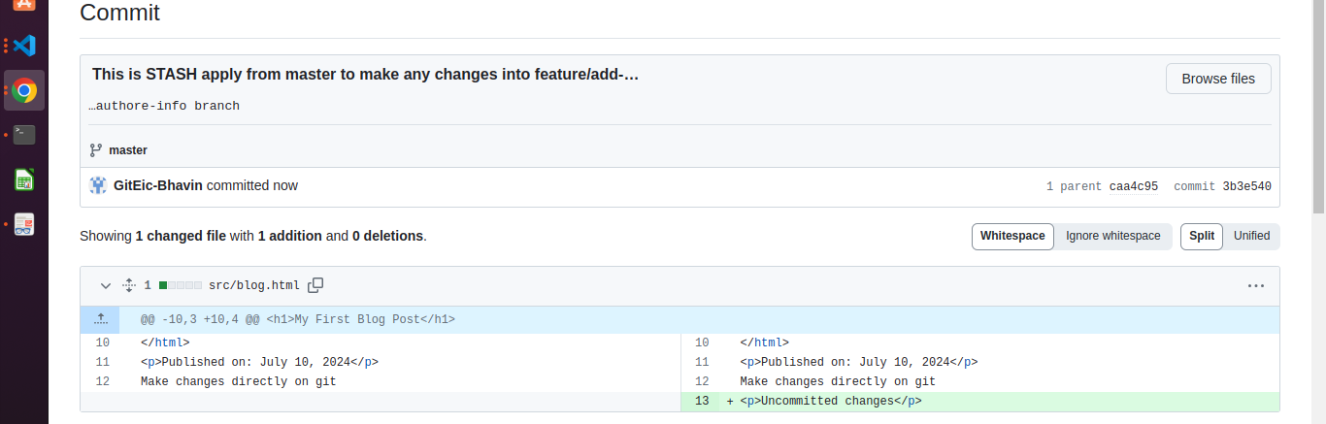
- Viewing Commit History:
Use git log to view commit history:
git log –oneline
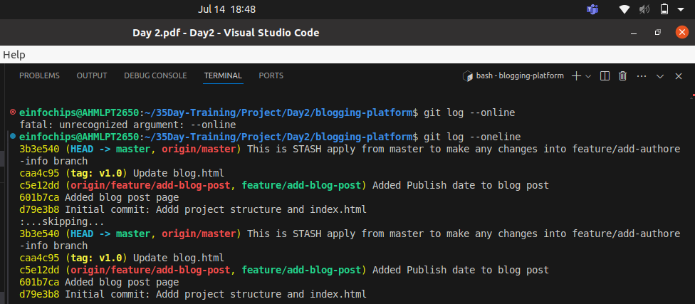
- Cherry-Picking Commits:
Create a new branch and cherry-pick a commit from another branch:
git checkout -b feature/cherry-pick
git cherry-pick <commit-hash>
If you cherry-pick a specific commit like caa4c95 from master to feature/cherry-pick branch. It will create merge conficts.
Bcz, you created feature/cherry-pick brach from master branch , so all files of master branch will comes in this feature/cherry-pick branch.

Now, you are trying to cherry-pick a specific commit like caa4c95.
In this commit only this will changes.
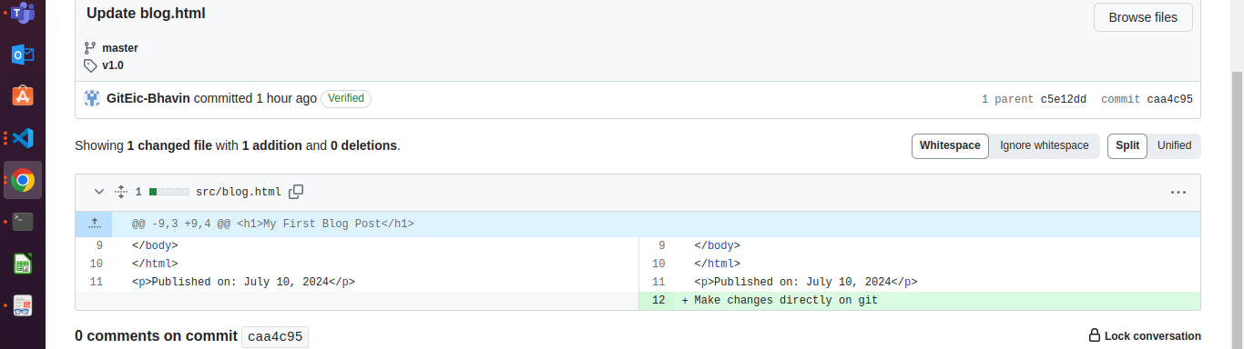
But, current status of feature/cherry-pick branch is.
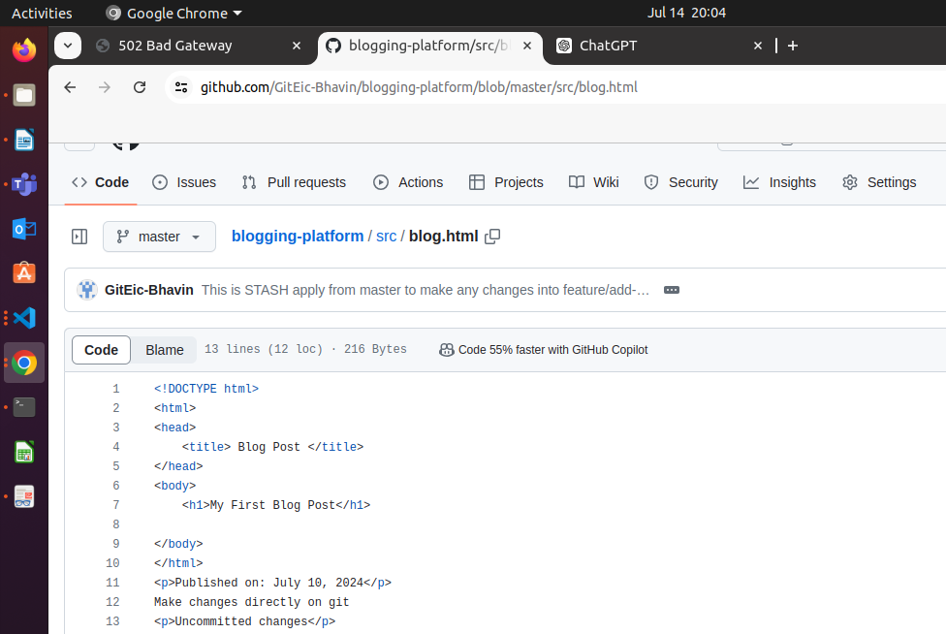

Bcz, you craeted this branch from master branch.

So, you have to solve metge confilcts fist.
# git add .
# git commit -m “This is cherry-pick conflicts solved of caa4c95”
# git push origin feature/cherry-pick

git push origin feature/cherry-pick
- Interactive Rebase:
Use interactive rebase to squash commits:
git checkout main
git rebase -i HEAD~3

Here, last 3rd commit was,
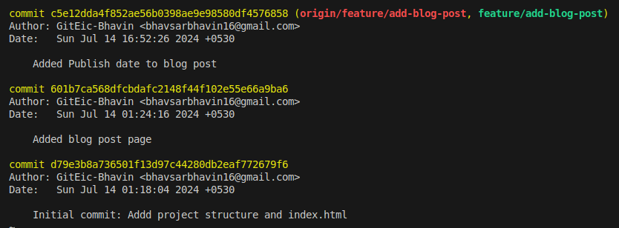
last commit

2nd last commit

3rd last commit

